

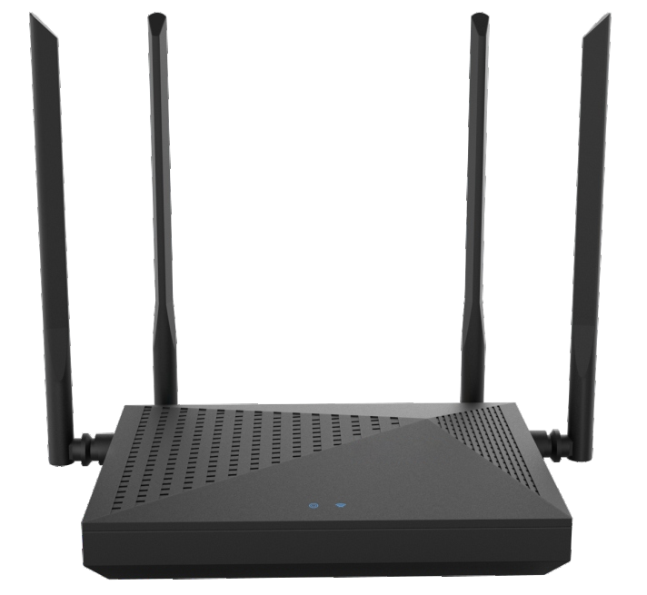

**SWR-1200L4**

**2100M Gigabit WIFI Router**

SWR-1200L4 is a 1200M 11AC dual-band wireless router specially designed for large-sized apartments with over 100Mbps FTTH network.The router is equipped with dual-core CPU and DDR3 memory,it enables the system to run fast and stably.

With 128MB large memory,it has a larger data cache space to guarantee game acceleration and more functions. The built-in independent PA / LNA signal enhancement module and external 4 high-gain omnidirectional antennas produce strong signal penetration performance,which truly help to achieve the full coverage of dual-band WIFI in villas and large-sized apartments. SWR-1200L4 is widely used in various applications such as wireless relay, LED light / WIFI timer switch, USB sharing etc. It is an ideal



**2**.**4G 5G**



Dual-band Dual-core CPU



Full Gigabit Ports



router for requirement of large coverage, signal penetration and smooth surﬁng.

4xOmnidirectional Antennas

MU-MIMO

Dual wireless CPU

Ipv6

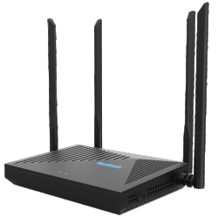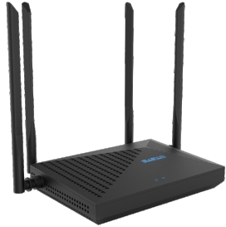

# 

# Specification

IEEE 802.11b/g/n 2.4GHz



WPS/Reset

CE, RoHS

**Button**

160×110×30mm

**W x D x H**

**Certiﬁcation**

**External Power Supply** 12VDC/1A

1×10/100/1000Mbps

**Interface WAN Port**

4×10/100/1000Mbps

**Interface LAN Ports**

128MB/8MB

**Memory/Storage**

MT7621D+MT7603E

+MT7613B

**Chipset**



2×2.4GHz

**Antenna**

**Wireless Modes**

2.4-2.5GHz;5.15-5.25GHz

**Frequency**

300Mbps(2.4GHz)

**Wireless Speeds**

**Wireless Standards**

IEEE 802.11ac/n/a 5GHz

867Mbps(5GHz)

Wireless Router; WISP; AP

2×5GHz

# Product Interface

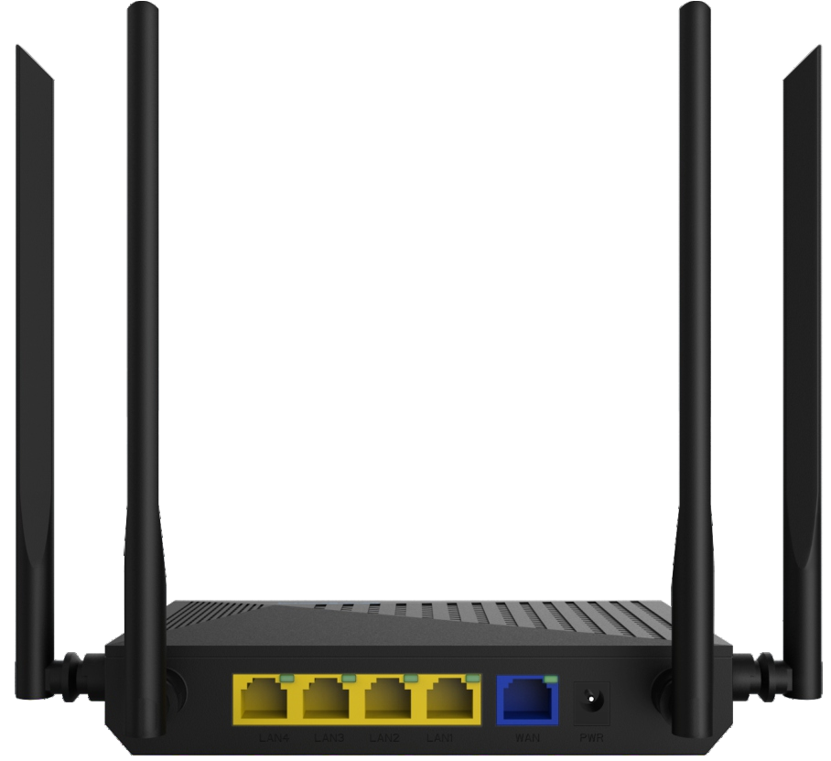

PWR

LAN WAN

